**Starting Neo4j CE V. 3.1.0:**

We are currently running Neo4j Enterprise Edition V 3.3.0. But after running V 3.3 I had to reboot in order to start the CE.

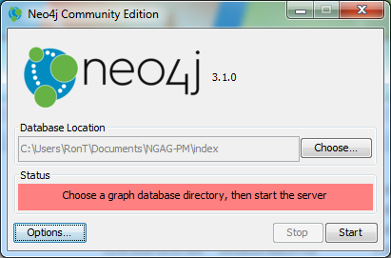

Options:

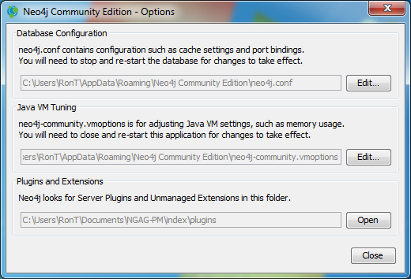

And then CE V 3.1.0 started (displaying the HTTP port number, next page):

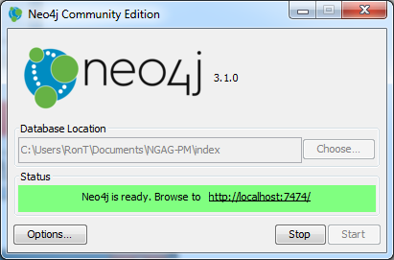From this document <https://neo4j.com/docs/operations-manual/current/configuration/ports/> it is clear that the web socket (port) depends on the protocol used: HTTP, HTTPS, and Bolt. The version of the Policy Machine we now have will not work by requesting access to a server running (and listening) at HTTP port 7474 (hard-wired into the PM Java code).

Opening the URI above took me to the database, with a saved ABAC section under Saved Scripts.